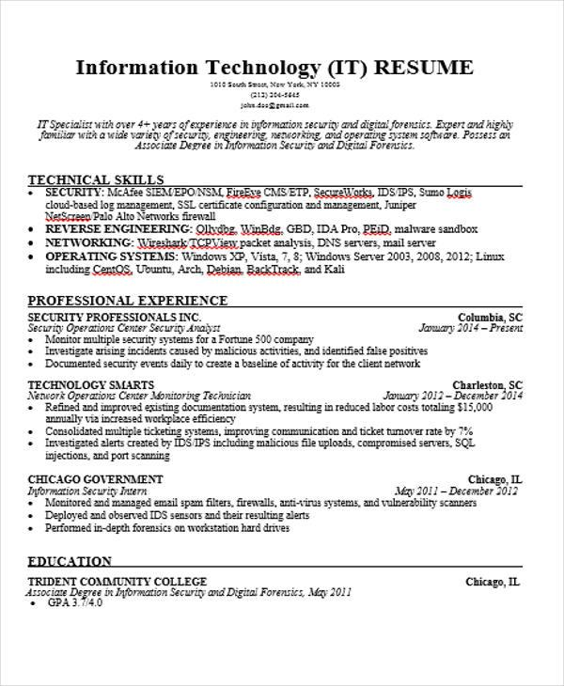
Information Technology (IT) RESUME
1010 South St, New York, NY 1000
(213) 204-5645 john.doo@gmail.com
IT Specialist with over 4+ years of experience in information security and digital forensics. Expert and highly familiar with a wide variety of security, engineering, networking and operating system software. Possess an Associate Degree in Information Security and Digital Forensics.
TECHNICAL SKILLS
SECURITY: McAfee SIEM EPO NSM, FireEve CMS ETP. SecureWorks, IDS/IPS, Sumo Logis cloud-based log management, SSL certificate configuration and management, Juniper NetScreen Palo Alto Networks firewall
⚫ REVERSE ENGINEERING: Oldg. WinBdg. GBD, IDA Pro, PEID, malware sandbox
⚫ NETWORKING: Wireshark TCPView packet analysis, DNS servers, mail server
⚫ OPERATING SYSTEMS: Windows XP, Vista, 7, 8; Windows Server 2003, 2008, 2012; Linux including CentOS, Ubuntu, Arch, Debian. BackTrack, and Kali
PROFESSIONAL EXPERIENCE
SECURITY PROFESSIONALS INC.
Security Operations Center Security Analyst
• Monitor multiple security systems for a Fortune 500 company
Columbia, SC
January 2014-Present
⚫ Investigate arising incidents caused by malicious activities, and identified false positives Documented security events daily to create a baseline of activity for the client network
TECHNOLOGY SMARTS
Network Operations Center Monitoring Technician
Charleston, SC
January 2012-December 2014
Refined and improved existing documentation system, resulting in reduced labor costs totaling $15,000 annually via increased workplace efficiency
Consolidated multiple ticketing systems, improving communication and ticket turnover rate by 7% Investigated alerts created by IDS IPS including malicious file uploads, compromised servers, SQL injections, and port scanning
CHICAGO GOVERNMENT
Information Security Intern
Chicago, IL
May 2011-December 2012
Monitored and managed email spam filters, firewalls, anti-virus systems, and vulnerability scanners Deployed and observed IDS sensors and their resulting alerts Performed in-depth forensics on workstation hard drives
EDUCATION
TRIDENT COMMUNITY COLLEGE
Associate Degree in Information Security and Digital Forensics, May 2011
•
GPA 3.7/4.0
Chicago, IL

